Site Visit Date: 25-07-2018

Property Charged (Map: 11.632485, 104.895951)

A unit of vacant land (under housing development project)

Address: K2 Village, Sangkat Chraing Chamres 2, Khan Russey Keo, Phnom Penh

Land size: 6,042 sqm

Site visited by Sok Ratanak, Moeurn Chheleang and Chiv Hak

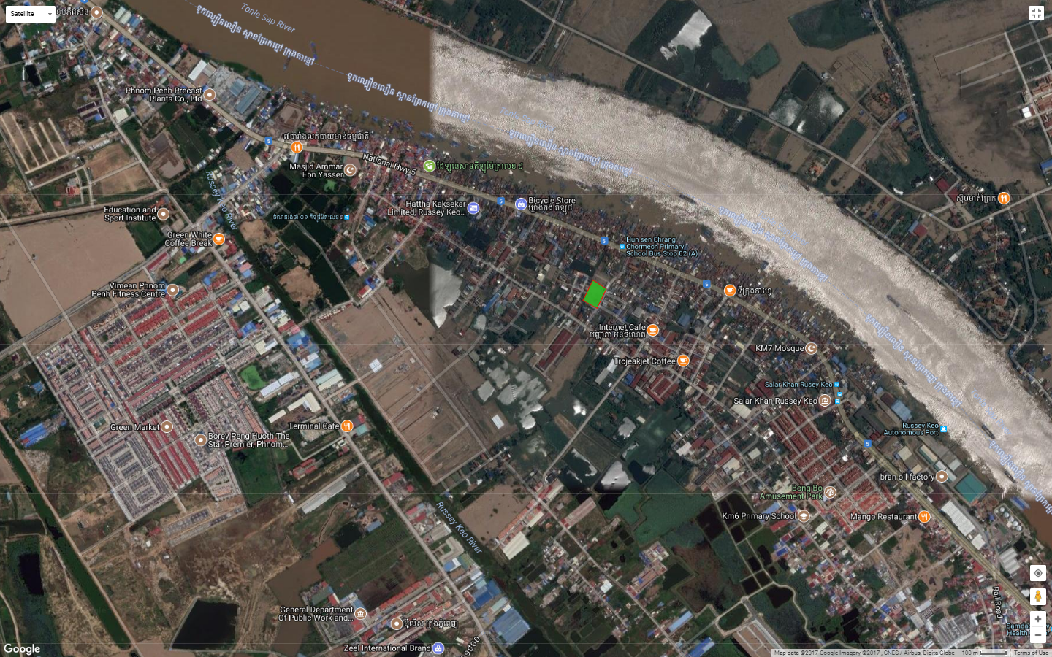

National Road 5

Subject Property

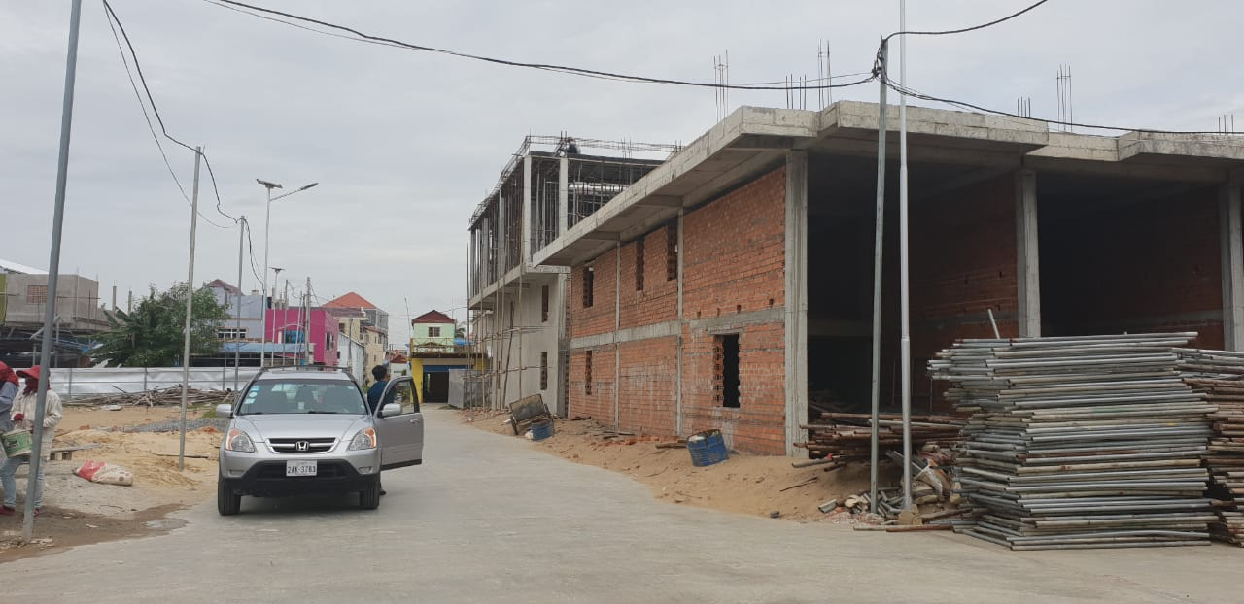

Property Charged (Map: 11.632485, 104.895951) A unit of vacant land (under housing development project)

Address: K2 Village, Sangkat Chraing Chamres 2, Khan Russey Keo, Phnom Penh (Land size: 6,042 sqm )

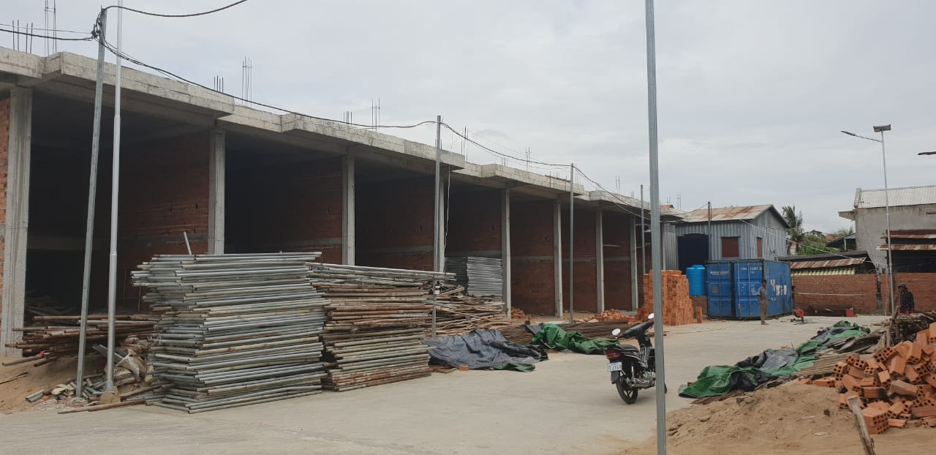

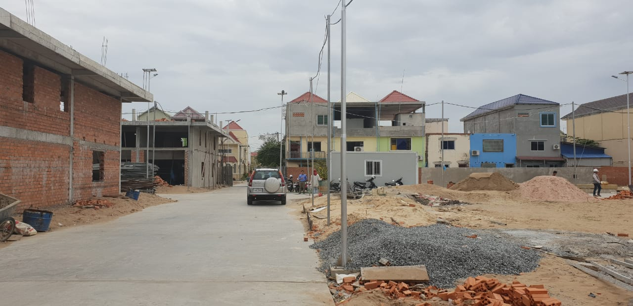

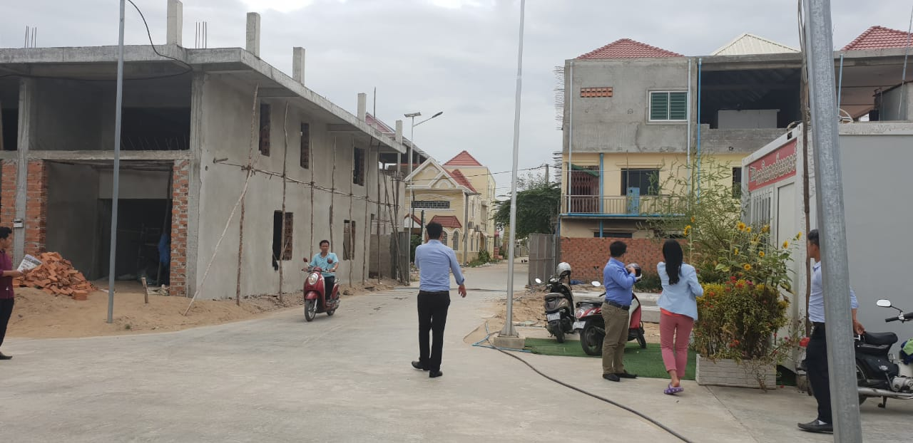

Gas Station Location

1. DEPO TELA SEVEN 598 GAS STATION

Address: along Street 598 (in front of Borey Vimean Phnom Penh), Svay Park Village, Sangkat Svay Park, Khan Russey Keo, Phnom Penh

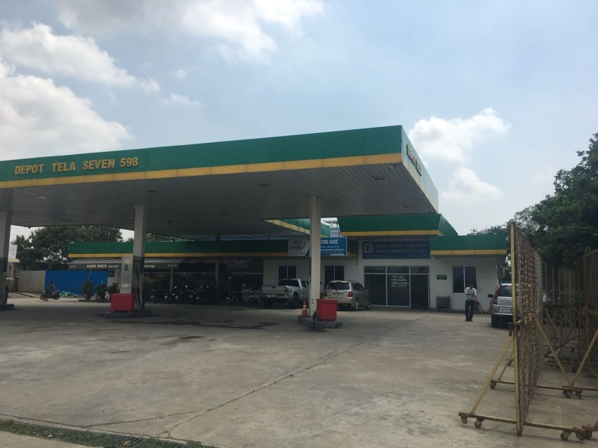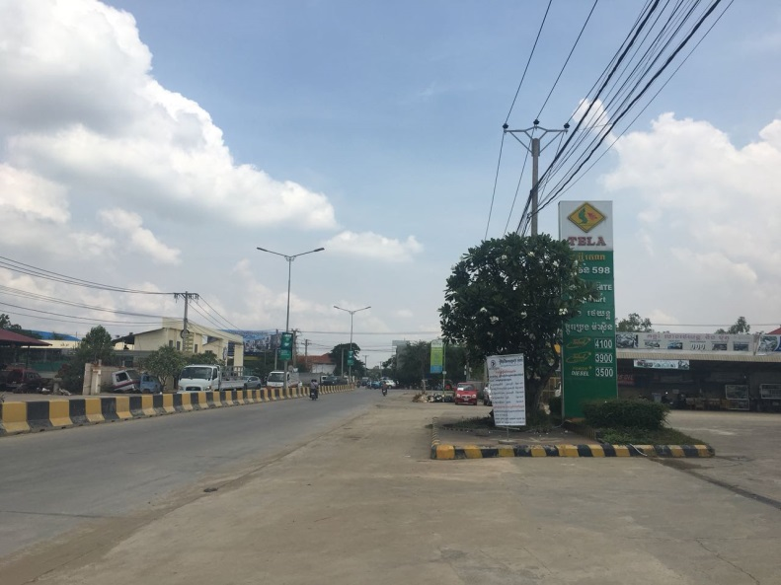

1. SAVIMEX SEVEN WAT TUOL (WT)

Address: along Street Betong (100m from Wat Tuol), Boeung Salang Village, Sangkat Russey Keo, Khan Russey Keo, Phnom Penh.

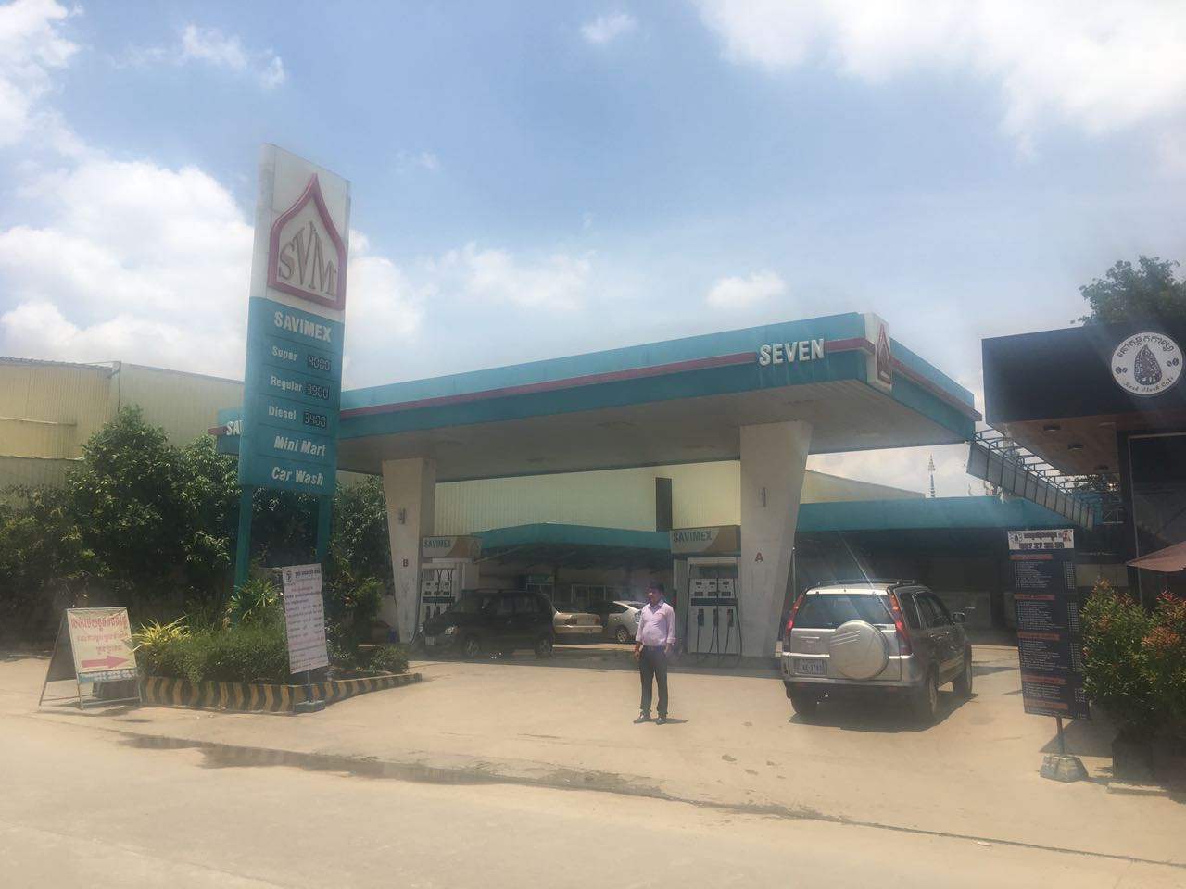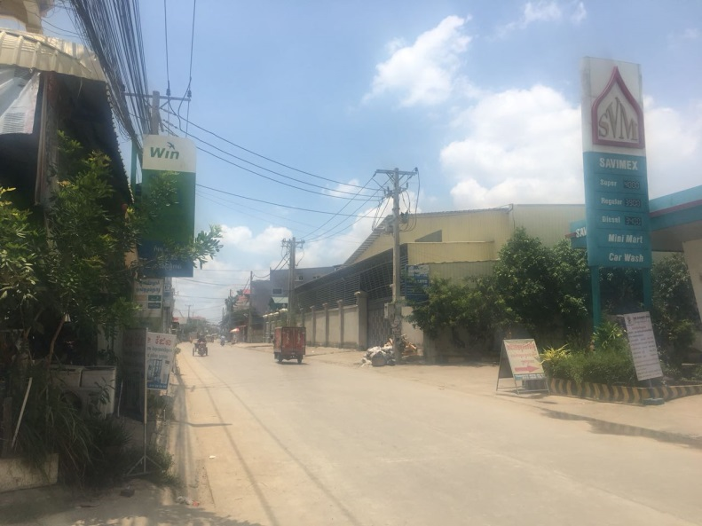

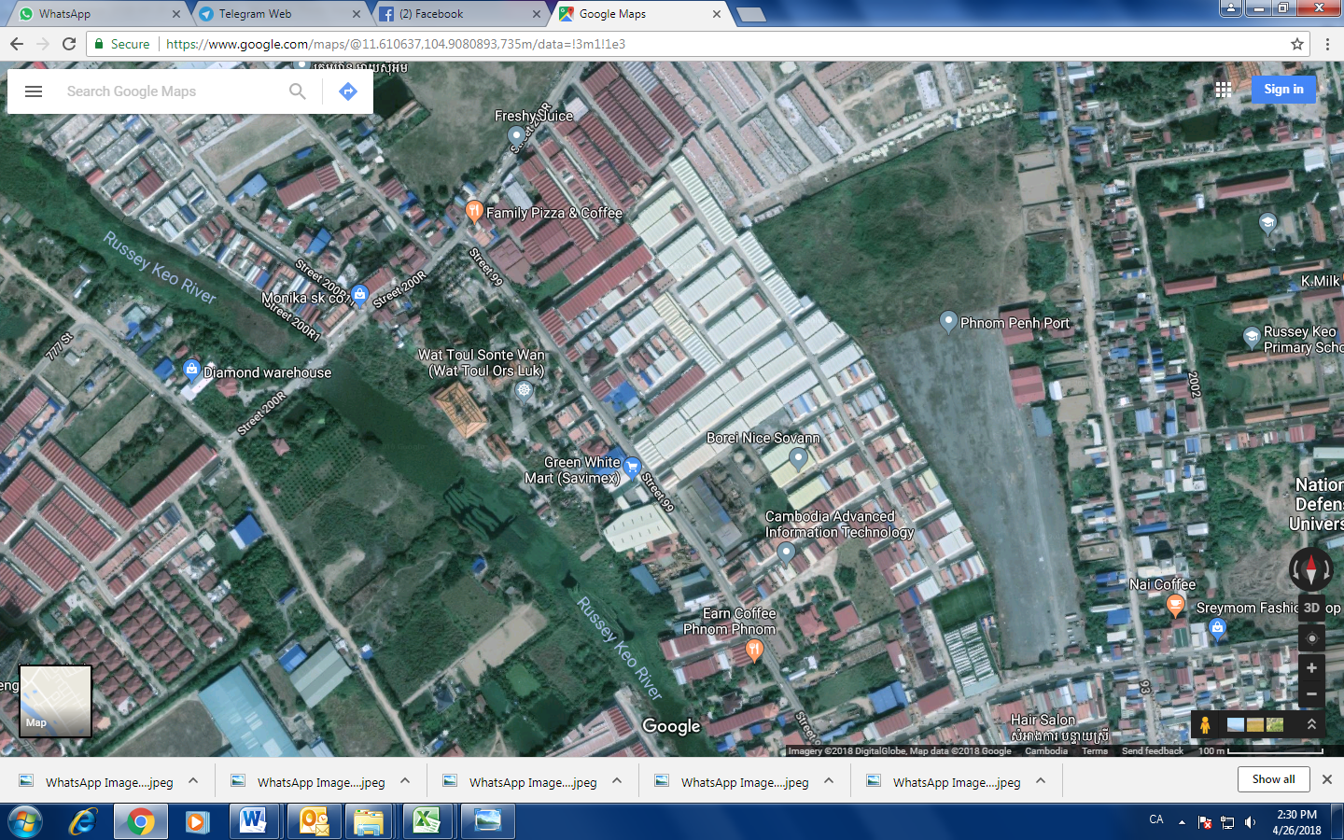

SAVIMEX SEVEN WAT TUOL (WT)

Tuol Pagoda

1. SEVEN TUOL SANGKE GAS STATION

Address: Along Street Betong, Tuol Sangke Village, Sangkat Tuol Sangke, Khan Russey Keo, Phnom Penh

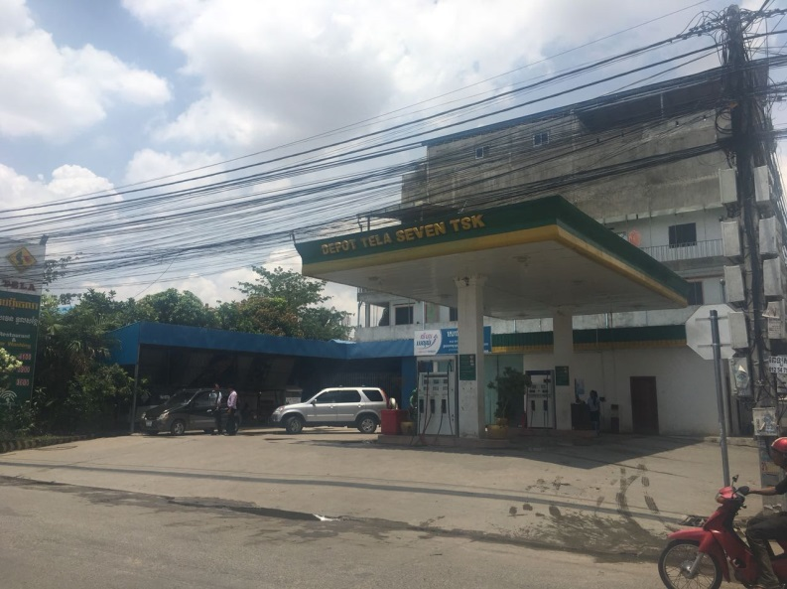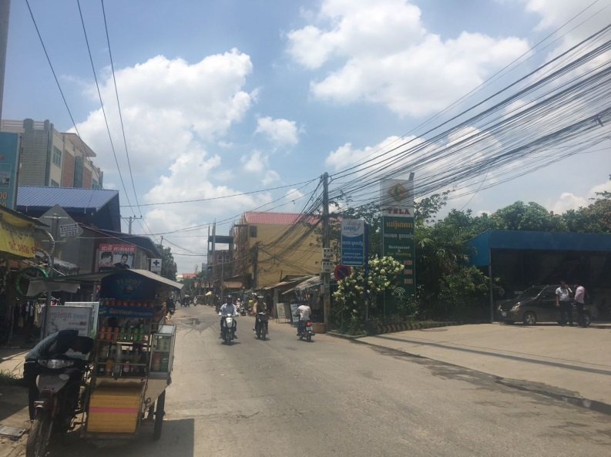

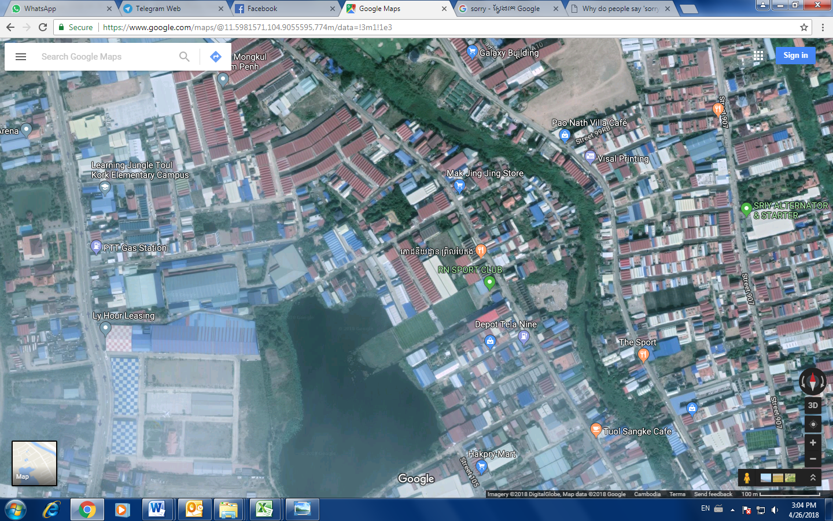

SEVEN TUOL SANGKE GAS STATION

Ly Hour Leasing (St. 598)

1. TELA SEVEN PORCHEN TONG (PCT)

Address: #1275, Chamkar Ovleuk Village, Sangkat Kakab, Khan Porsenchey, Phnom Penh

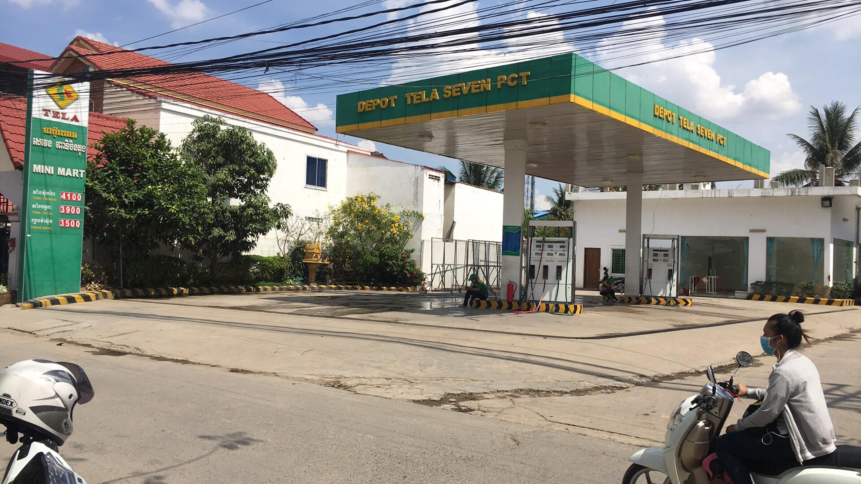

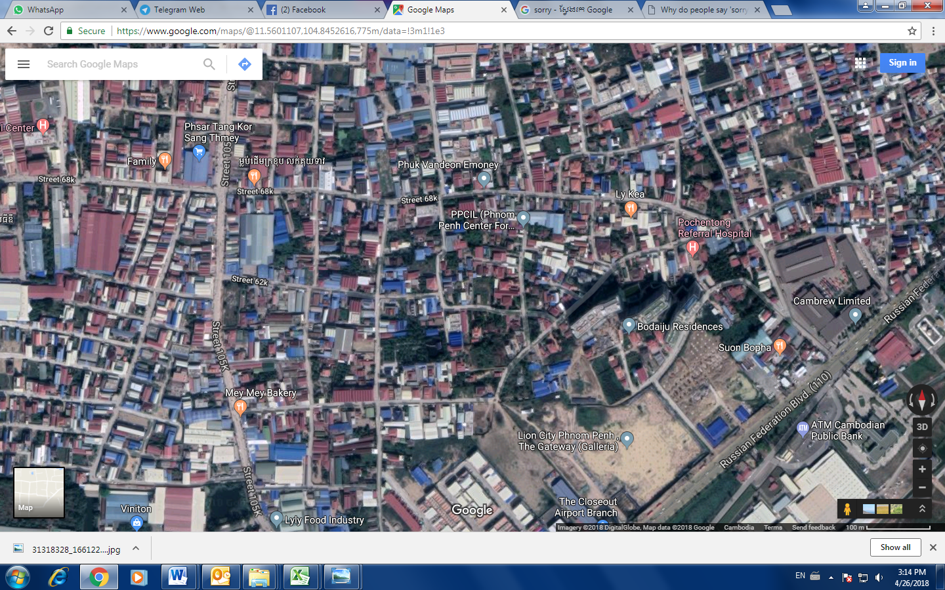

TELA SEVEN PORCHEN TONG (PCT)

Tang Kor Sang Market

1. SAVIMEX PHNOM PENH THMEY

Address: Street 1986, Phnom Penh Thmey Village, Sangkat Phnom Penh Thmey, Khan Sensok, Phnom Penh

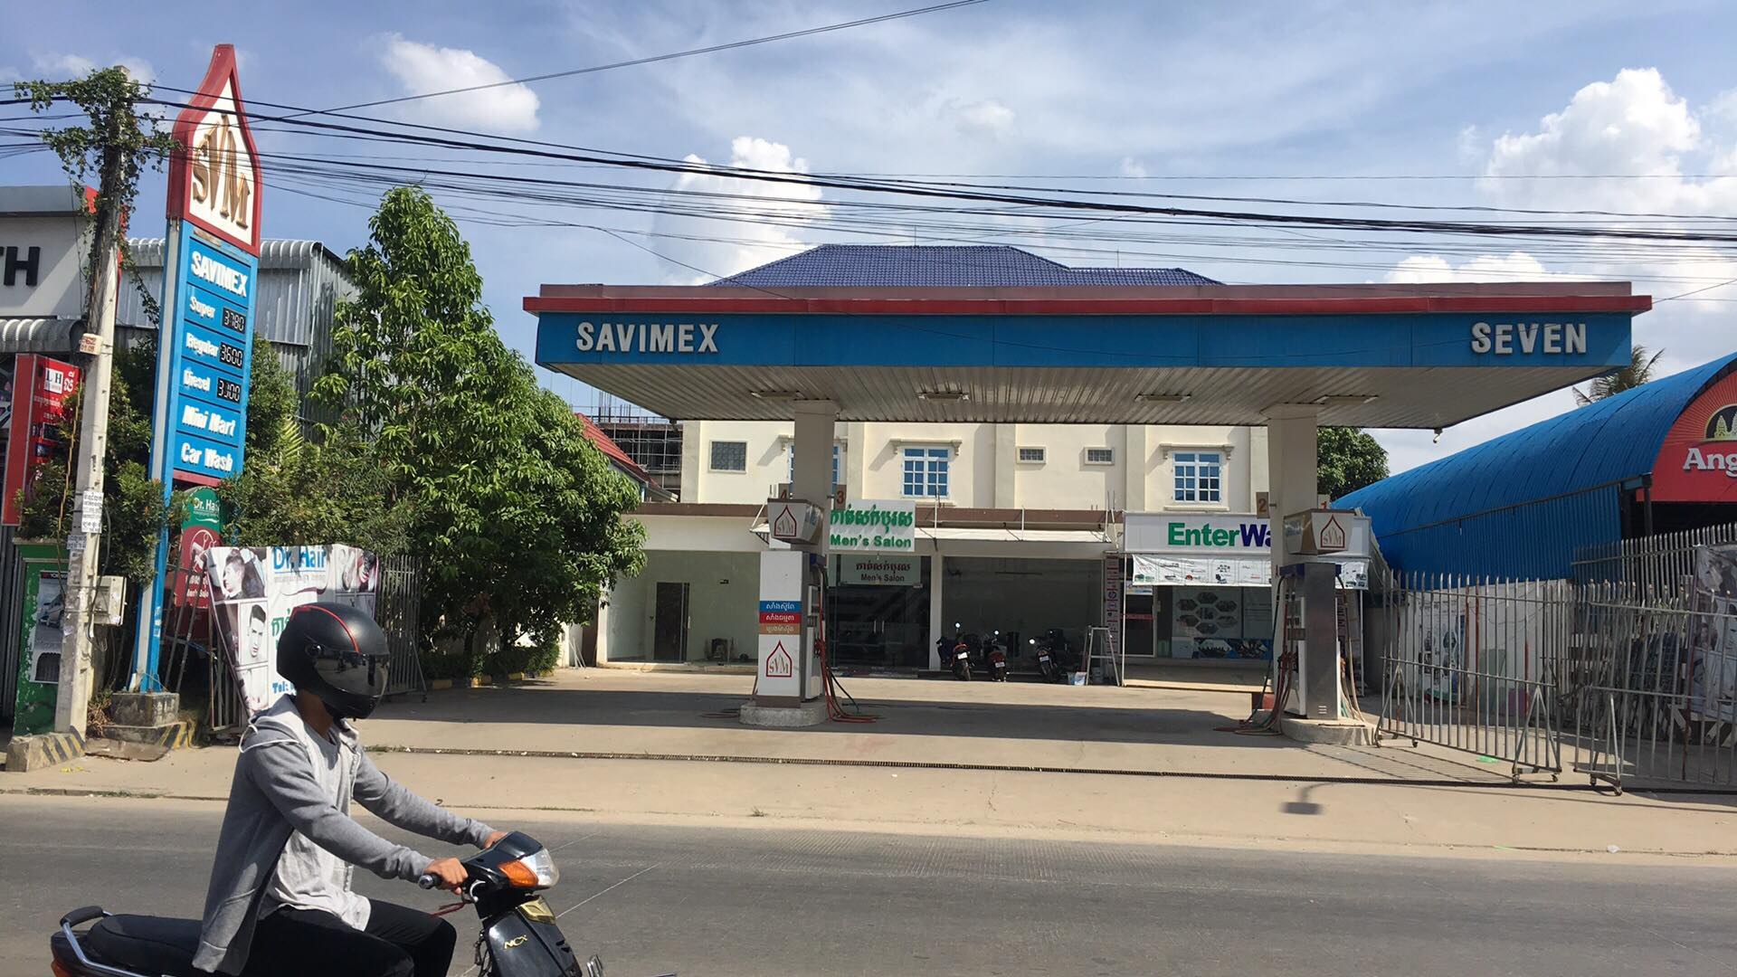

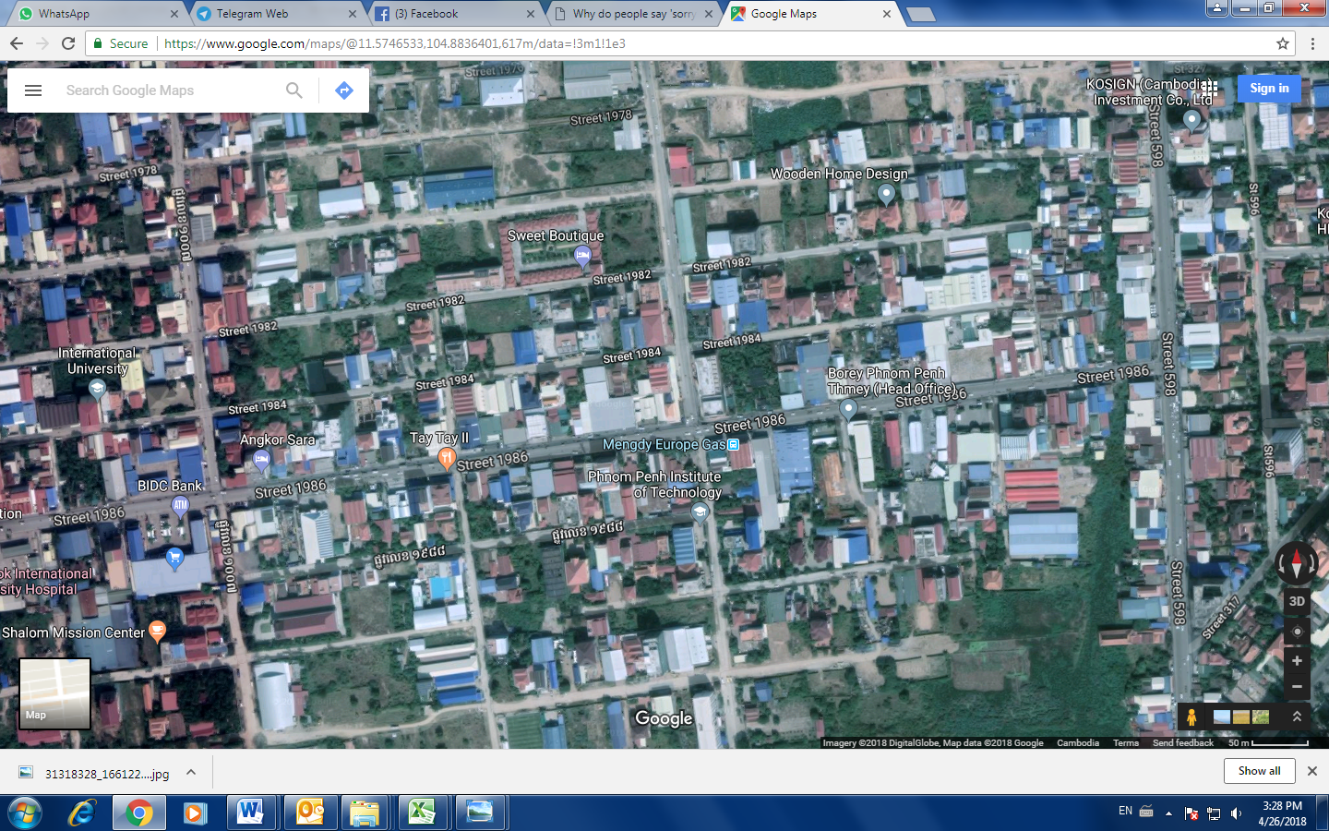

SAVIMEX PHNOM PENH THMEY